Token
General requirements for theses.
To indicate the range of values, put: three dots.
The designation of physical quantities cannot be separated from the numeral form of the value of these quantities, that is, it cannot be transferred to the next line, for this use a "non-breaking space" (key combination shift+ctrl+space).
The calendar date must be expressed as a year, month and day of the month: 1997-03-14.
Requirements and recommendations for the thesis file.
The file should not contain extra characters and non-printable characters. To do this, it is necessary to enable the mode of non-printable characters in the menu ( 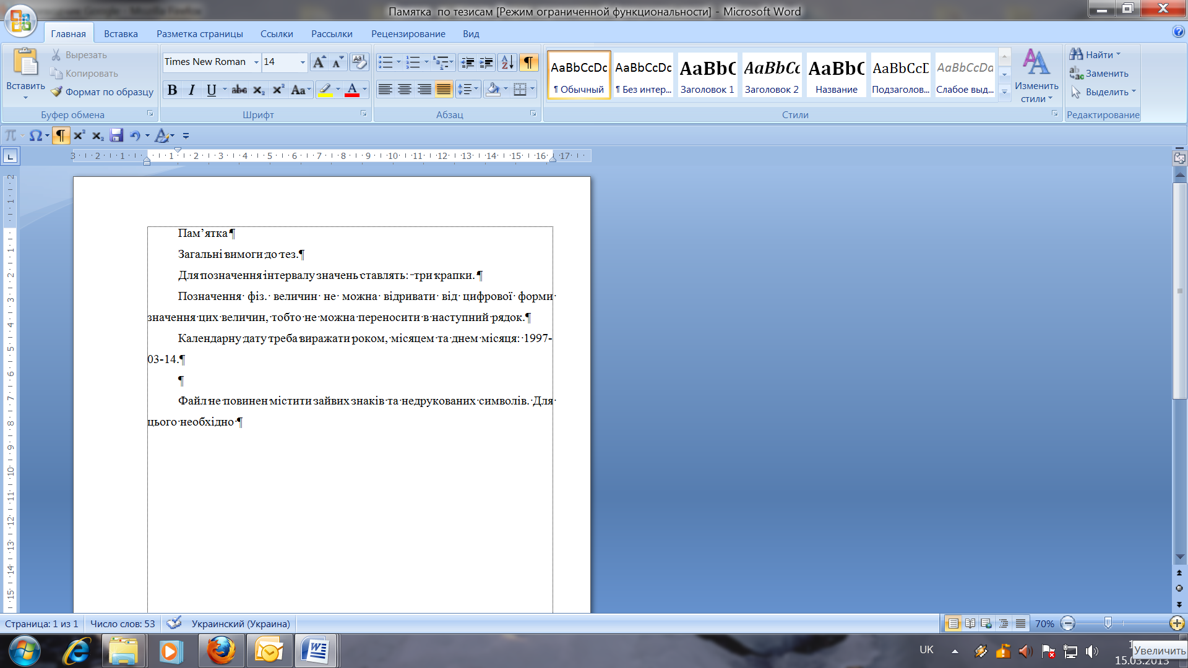) and remove all extraneous characters.
The faculty file is called by its abbreviated name.
The file provided to you contains examples of the types of presentation of material used in theses: text of thesis, figures, formulas and tables in three languages (Ukrainian, English and Polish). Examples in redundant languages are deleted. The example is made in compliance with all requirements. Different types of material are made in the form of different styles.
The list of styles is as follows
The name of the style | Type of material
UDK | JEL
Authors eng. | Authors name and surname
Authors’ position | Positions of theses authors
Title of theses eng. | Title of theses
The text of theses eng. | Text material of theses
Figures eng. | Figures and captions
Formula | Formulas
Form. text. eng. | Deciphering formulas, sub-formula text
The name of tabl.eng. | The name of the tables
Text tabl. eng. | Content of the table
Literature | Title «References»
Text theses eng. | Content of References’ list

If one of the forms of materials submission is missing, it is deleted.
If necessary, the template is copied, while selecting the parameters of the "Save original formatting" option.
The material is inserted into the file in parts separately (JEL, Authors name and surname, Title of theses, ets) at the same time, it is necessary to select "Save styles of the final fragment" in the insertion parameters. Or, after inserting all the material, assign each part a separate style that should be. The "Style" submenu is located in the "Format" menu (MS Office 2003) or in the Main menu (MS Office 2007).

